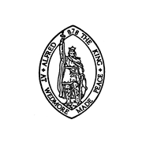

Wedmore Parish Council
Notice of conclusion of audit Annual Governance & Accountability Return for the year ended 31 March 2023
Sections 20(2) and 25 of the Local Audit and Accountability Act 2014
Accounts and Audit Regulations 2015 (SI 2015/234)
1.The audit of accounts for Wedmore Parish Council for the year ended 31 March 2023 has been completed and the accounts have been published.
2. The Annual Governance & Accountability Return is available for inspection by any local government elector of the area of Wedmore Parish Council on application to:
(a) Lindsey Baker, Clerk & RFO for Wedmore Parish Council,
The Council Office, Grants Lane, Wedmore Somerset, BS28 4EA
(b) At hours to be agreed on an individual basis, usually between 9:00am and 5:00pm Monday to Friday.
3. Copies will be provided to any person on payment of £5.00 for each copy of the Annual Governance & Accountability Return.
Announcement made by: Lindsey Baker, Clerk & RFO
Date of announcement: 27th September 2023

